Memeber 1: Sharvayu Zade - 230700521135
Member 2: Shreya Bansal - 23070521144
Practical 07 Activity
1. To-Do List With a Twist (Emoji Mode)
● What to build:
A basic to-do list, but every task must have an emoji selected from a dropdown.
● DOM Skills:
getElementById to get input and dropdown values.
createElement to create new list items.
appendChild to display the task with emoji.
querySelector to select tasks for edit/remove.
Extra fun challenge:
● Add a “Random Emoji” button that automatically selects a random emoji from a predefined array. 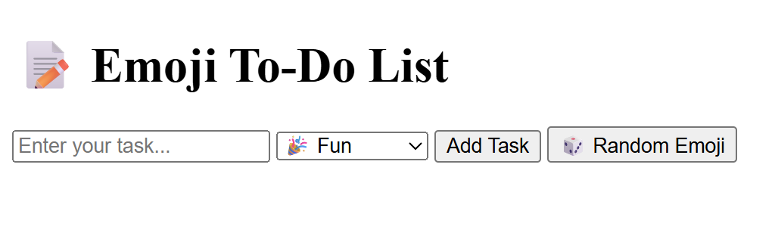
2. Color Palette Game
● What to build:
Generate 5 random colored boxes when the user clicks a button.
● Gameplay twist:
The system displays a target color code (e.g., #FF5733).
The student must click the box with the correct color.
When clicked, highlight it as “Correct” or “Try Again”.
● DOM Skills:
Create color boxes using createElement.
Use appendChild to add to the DOM.
Use querySelector to track clicks.
3. Build Your Own Quiz
● What to build:
A multiple-choice quiz where questions are generated dynamically from an array.
● Steps:
Store questions and answers in a JSON array.
Dynamically create question <div>s using createElement.
Allow user to select and submit answers.
Show score dynamically.
● Extra challenge: Add a timer using setInterval.
4. Random Joke or Quote Generator
● What to build:
A “Get Joke” button that displays a random joke or motivational quote each time it’s clicked.
● DOM Skills:
querySelector for selecting the joke area.
createElement to create <p> tags.
appendChild to insert them dynamically.
● Extra challenge:
Add a “Like” button to each joke and count total likes.
5. Student Scoreboard
● What to build:
A mini scoreboard to add and update students’ scores.
Steps:
Enter student name and score in input fields.
Display them in a table using createElement and appendChild. Allow updates when you click on a score (inline edit).
Remove a student by clicking a delete button.
● DOM Skills: Perfect for practicing DOM traversal and element manipulation.
6. DOM Treasure Hunt
● How it works:
Hide 5 <div> elements with treasure emojis randomly on the page. The student must find and click them using only querySelector or getElementById.
Each correct click changes the emoji to a treasure chest and increases the score.
● Extra challenge: Add a timer countdown to make it exciting.
7. Digital Dice Roller
● What to build:
A page with a “Roll Dice” button that displays:
A dice face (emoji or number 1-6).
A running total of all rolls.
● DOM Skills:
createElement for dice.
appendChild for results history.
querySelector for total updates.
Fun extension:
● Create a two-player version and display who wins.
8. Simple Meme Maker
● What to build:
A user uploads an image and types text for the top and bottom.
● DOM Manipulation:
createElement('img') for uploaded image.
appendChild to place text on the image.
querySelector to update text dynamically.

